ERD

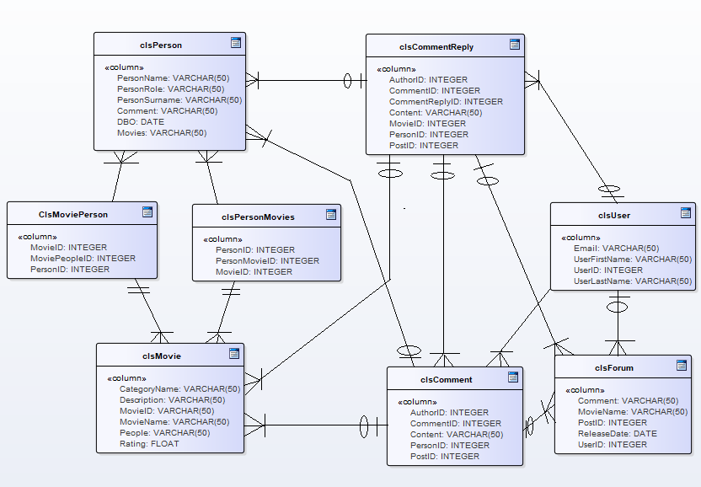

MovieID: int

Table Definition:

clsMovie(MovieID, CategoryName, Description, MovieName, People, Rating)

clsMoviePerson(MovieID, MoviePeople, PersonID)

clsPersonMovies(PersonID, PersonMovieID,MovieID)

clsPerson(MovieID, PersonName, PersonRole, PersonSurname, Comment DBO,Movies)

clsCommentReply(AuthorID, CommentID, CommentReplyID, Content, MovieID, PersonID, PostID)

clsComment(AuthorID, CommentID, Content, PersonID, PostID)

clsUser(Email, UserFirstName, UserID, UserLastName)

clsForum(Comment, MovieName, PostID, ReleaseDate,UserID)